PART I: Conversational AI System for a Small Business Entity (20 Points)

5. 1 Decision on Small Business Entity

TO-DO
- It is assumed that each team is a small company or business.
- Brainstorm and discuss with team members to decide a small business entity, such as a coffee shop or a small retailer, of which the team will develop a conversational AI system.
Answer:
- Our team brainstormed with different ideas like cleaning and car rental.
- We finalized car rental due to the practical problems faced by people when arriving in new cities which include:
  - late night arrivals
  - unreliable/stale information
  - complicated process to book a car rental
  - delays due to high volume of customers etc.

5.2 Teamwork Evaluation
1. What group do you belong to? (Provide the group number)
Answer: group 6
- Who are the members of your group?
Answer:
- Paladugu, Sheba Rani
- Shah, Rinal
- Sabnam, Sonali
- Xiong, Tao
- Anne, Rajesh
- Have the members organized any meeting (ONLINE or IN-PERSON) to work on HW 4?
Answer: Yes, we meet online on Thursdays and before class on Mondays.
- If YES to #3, which members, including the student himself/herself, showed up in the meeting?
Answer: All the members showed up in the meeting.
Paladugu, Sheba Rani
Shah, Rinal
Sabnam, Sonali
Xiong, Tao
Anne, Rajesh

- If YES to #3, do all the members make good efforts to actively participate in the group work?
Answer: Yes

- If NO to #5, do you have any opinions to share about the group?
Answer: All team members are contributing their ideas. We are having engaging discussions.

PART II: Business and Technical Requirements of the System (30 Points)

TO-DO
Question: Based on the business type of the small business entity:
- Document the business values of the conversational AI system to create ▪ Why does the company
Answer:
The idea revolves around a set of business values keeping the customer requirements in mind. The business values also cater to the revenue generation of the organization.
business values:
- Convenient Conversational Interface: Chatbot is a convenient interface for interaction
- Handle essential tasks: car options, availability, booking, manage payments
- Availability: 24 X 7 available: The chatbot does not have any human dependency hence it is available all days, throughout the day.
- Seamless Integration: The chatbot can be integrated easily with the existing system
- Real time information: As the chatbot is an automated system, it would have access to updated/real-time information.
- Data Privacy: As there is no human intervention, it reduces the chances of errors leading to data privacy issues.

Question: Document the business requirements of the conversational AI system to create
- For example: Open schedule of the store, i.e., date and time when the virtual agent
  - is available for customers to “talk” with.
Answer:
The business requirements for the chatbot are based on the customer experience and revenue generation.
business requirements
- Enhanced customer experience: People often face get frustrated while booking a car rental as it is a time-consuming process. Our chatbot focuses on providing an enhanced customer experience.
- Convenient and automated system: As the chatbot is fully automated, it cuts down the wait time.
- Reduced operational cost for customer support: As the chatbot works without human intervention, it reduces the cost significantly.
- Efficiency: Increased efficiency as the chatbot can handle multiple customers’ requests once
- More revenue, retention and satisfaction: The chatbot implementation increases revenue, customer retention and satisfaction due to low waiting times and information accuracy.

Question: Document the technical requirements of the conversational AI system to create.
  - For example:
    - Which AI platform will be used to create the conversational AI system?
Answer:
The conversational chatbot will be developed using DialogFlowCX by Google cloud platform. This platform provides us the required resources to build a chatbot which can handle complex conversations involving multiple intents and flows. With DialogFlowCX, we can also test the chatbot and improvise.

Question: GCP Dialogflow CX.

▪ What kinds of components or subsystems, i.e., flows, pages, intents, …, must be created to create the system?
Answer:
Components Used:
- Flows
There are multiple flows that we have identified for building this chatbot. Some of them are shown below. Please note that these not the final flows, we are still working on it.
  - Catalog
  - My Booking
  - My Booking Cancellation
  - My Booking Status
  - Customer Care
  - End Flow
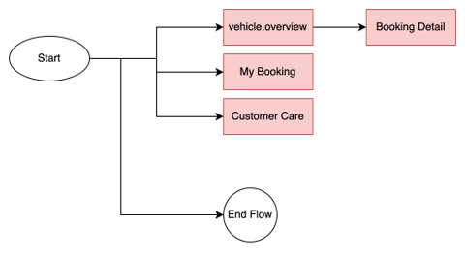

- Pages:
We have designed a few pages with respect to the flows identified so far.
Some of them are shown below.
  - Start page
  - Type overview
  - Seater
  - Price
  - Fuel type
  - Vehicle class overview
  - Drive type
  - Insurance
  - Confirmation
  - End session
  - End Flow
  - Booking details
  - My reservations

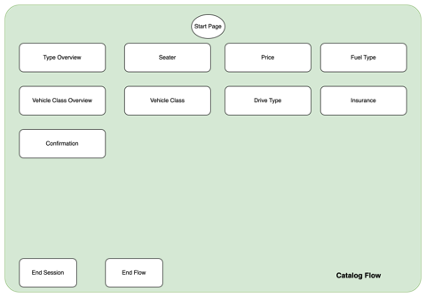

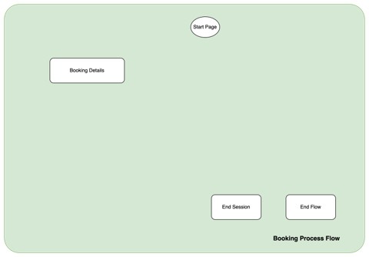

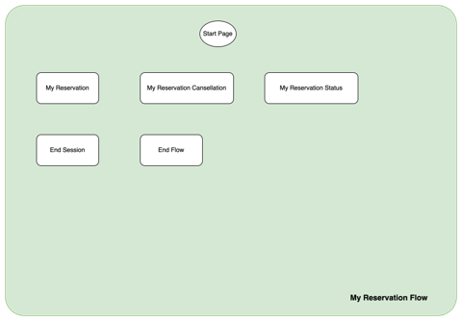
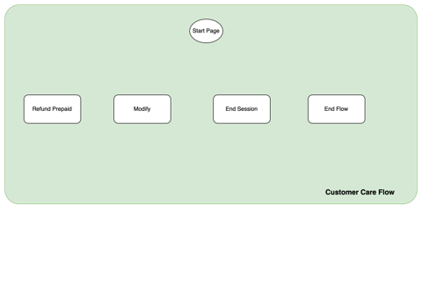
- Intents:
We have identified some intents based on our mock booking conversation and brainstorming sessions.
  - redirect.vehicle.overview
  - redirect.services
  - redirect.car.insurance
  - redirect.my.booking
  - redirect.price
  - redirect.my.booking.status
  - redirect.my.booking.canceled
  - redirect.refund.info
  - redirect.booking.process
  - confirm.proceed.booking
  - decline.proceed.booking
  - redirect.home
  - redirect.end
  - redirect.location

PART III: Data Model Requirements (50 Points)
TO-DO
Question: Based on the business type of the small business entity, document the data needed to create the conversational AI system.
- The student should use the data provided in the codelab project (G-Records) as a sample to document the data required for the conversational AI system to create.
Answer:
We have created the data model shown below. We have presented the same in the class.
- Vehicle class

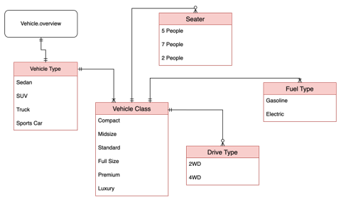
- My Booking
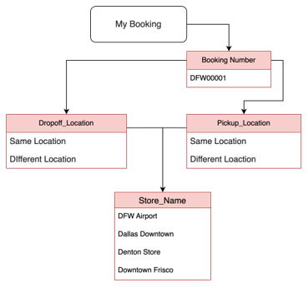
- Customer Care
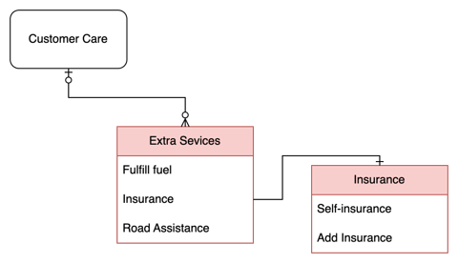
- Booking Detail
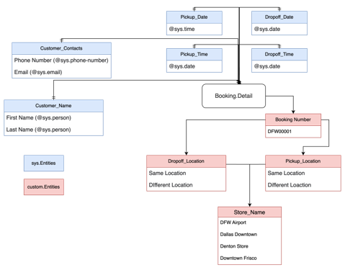

We have also created the below mentioned “Intent to Entity Mapping”.
- Redirect.vehicle.overview
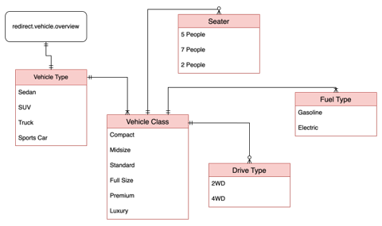
- Redirect.services
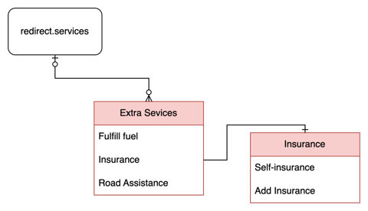
- My.booking
